**Define Problem / Problem Understanding**

**Literature Survey**

|  |  |
| --- | --- |
| **Team Id** | **NM2023TMID04415** |
| **Project Name** | **Block chain Technology For Electronic Health Records** |

**Categorization of Articles:**

We categorized the final 75 articles by study design, theoretical/conceptual framework, organizational setting, health IT type or function, and study perspective and implementation stage. We found that the research articles used a wide range of study designs, including literature reviews, quantitative, qualitative, and mixed methods, including case studies or profiles of single and multiple organizations, and cross-sectional rather than longitudinal data and analyses (Table 2). We differentiated between case studies and profiles of organizations by classifying articles that had more rigorous study design (with a stated methods or framework, for example) as case studies, and those that did not as profiles.

**Technical Perspective:**

A number of articles addressed considerations made during the EHR/health IT selection process, as well as strategies for how this technology would be acquired and integrated into existing systems. These choices also take into account important partnerships that providers form in this process, such as with vendors or other health care organizations with whom they might share technology and data. By design, federally funded RECs are available across the country as a resource for small practices or providers working in safety-net settings in need of assistance during the planning stage and all other stages of the implementation process, focusing on issues such as vendor selection, privacy and security, workforce development, and MU. While RECs have been an important resource for smaller physician practices and CAHs that may not be connected with any larger hospital, they did not show up as a key theme in our review, as our focus was on larger health care systems.

**Professional Group Perspectives:**

**The perspectives of front line clinical, ancillary (pharmacy, radiology, etc.) and administrative staff (ultimate end-users), clinical units, and managers are also important to consider in the planning stage. Much of the literature was written from the perspective of managers or leaders in the organization who must communicate and coordinate the implementation of health IT. Many papers described the general needs and concerns of various professional groups and emphasized the importance of obtaining buy-in from the end users of the EHR system from the start.**

**Tables and Figures:**

**Framework for “Lessons Learned” Literature Review**

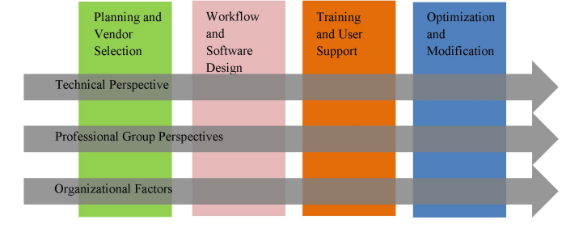Article Selection Flow Chart**:**



List of Literature Review Search Terms:

